Distributed Commodities OTC Electronic Trading System

Software Architecture Document

Version 1.0

Revision History

|  |  |  |  |
| --- | --- | --- | --- |
| **Date** | **Version** | **Explanation** | **Author** |
| 08/06/2014 | 1.0 |  | Bi Jianshui |
|  |  |  |  |
|  |  |  |  |
|  |  |  |  |

Contents

1. Introduction 4

1.1 Purpose 4

1.2 Reference material 4

2. Use case diagram 4

3. System architecture 5

4. Data view 5

4.1 Broker Trade Server 5

4.2 Trader Server 6

5. Core algorithm design 6

Software Architecture Document

# Introduction

## Purpose

This document will be the framework of a comprehensive overview of aspects of the system, which will use a variety of different architectural views to describe various aspects of the system. It is used to record and express important decisions have been made ​​on the aspects of the system's architecture.

## Reference material

# Use case diagram



# System architecture

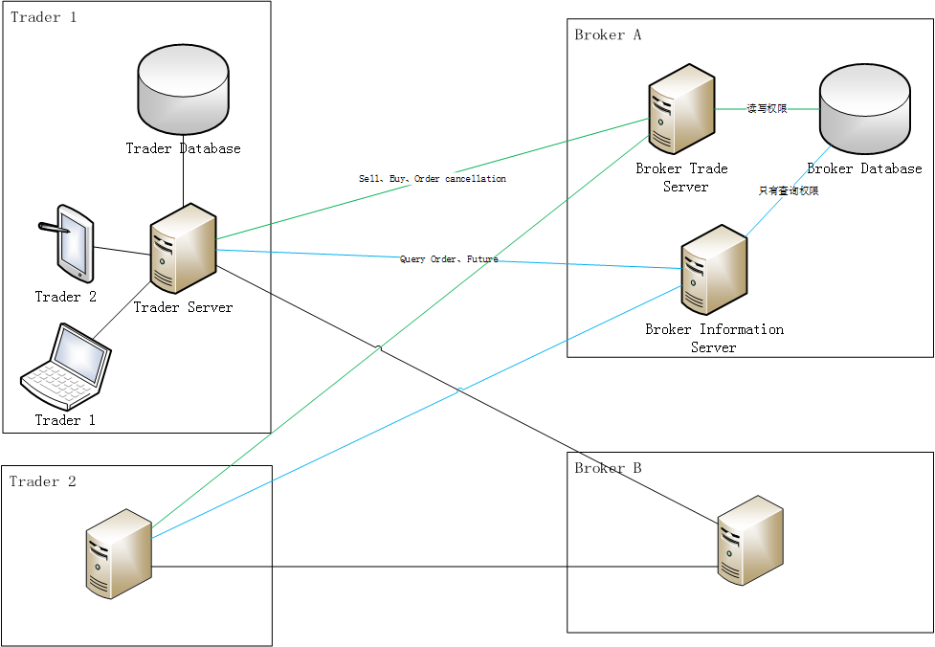

# Data view

## Broker Trade Server

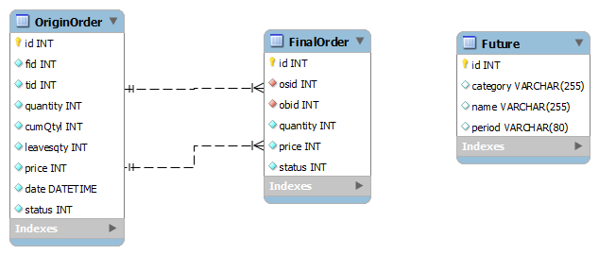

## Trader Server

# Core algorithm design

